Вариант 114

# Домашняя работа 4

Исходная таблица:

|  |  |  |  |  |  |  |  |  |  |  |  |  |
| --- | --- | --- | --- | --- | --- | --- | --- | --- | --- | --- | --- | --- |
| V/V | e1 | e2 | e3 | e4 | e5 | e6 | e7 | e8 | e9 | e10 | e11 | e12 |
| e1 | 0 | 2 | 2 | 5 | 5 |  |  |  |  |  |  |  |
| e2 | 2 | 0 |  | 1 | 1 | 3 | 3 | 4 |  |  |  |  |
| e3 | 2 |  | 0 |  | 4 |  |  |  |  |  |  |  |
| e4 | 5 | 1 |  | 0 | 5 | 2 | 2 |  | 4 | 5 | 2 | 2 |
| e5 | 5 | 1 | 4 | 5 | 0 |  | 2 | 2 | 3 | 1 |  | 4 |
| e6 |  | 3 |  | 2 |  | 0 |  |  |  |  |  | 3 |
| e7 |  | 3 |  | 2 | 2 |  | 0 |  | 5 |  |  |  |
| e8 |  | 4 |  |  | 2 |  |  | 0 | 4 | 3 |  | 2 |
| e9 |  |  |  | 4 | 3 |  | 5 | 4 | 0 | 1 | 1 | 4 |
| e10 |  |  |  | 5 | 1 |  |  | 3 | 1 | 0 |  | 3 |
| e11 |  |  |  | 2 |  |  |  |  | 1 |  | 0 |  |
| e12 |  |  |  | 2 | 4 | 3 |  | 2 | 4 | 3 |  | 0 |

Гамильтонов цикл: S={e1,e2,e6,e12,e8,e10,e4,e11,e9,e7,e5,e3}

Матрица смежности (с перенумерованными вершинами, хi – новые вершины):

x1 x2 x3 x4 x5 x6 x7 x8 x9 x10 x11 x12

|  |  |  |  |  |  |  |  |  |  |  |  |  |
| --- | --- | --- | --- | --- | --- | --- | --- | --- | --- | --- | --- | --- |
| V/V | e1 | e2 | e6 | e12 | e8 | e10 | e4 | e11 | e9 | e7 | e5 | e3 |
| x1 (e1) | 0 | *1* |  |  |  |  | 1 |  |  |  | 1 | 1 |
| x2 (e2) | 1 | 0 | *1* |  | 1 |  | 1 |  |  | 1 | 1 |  |
| x3 (e6) |  | 1 | 0 | *1* |  |  | 1 |  |  |  |  |  |
| x4 (e12) |  |  | 1 | 0 | *1* | 1 | 1 |  | 1 |  | 1 |  |
| x5 (e8) |  | 1 |  | 1 | 0 | *1* |  |  | 1 |  | 1 |  |
| x6 (e10) |  |  |  | 1 | 1 | 0 | *1* |  | 1 |  | 1 |  |
| x7 (e4) | 1 | 1 | 1 | 1 |  | 1 | 0 | *1* | 1 | 1 | 1 |  |
| x8 (e11) |  |  |  |  |  |  | 1 | 0 | *1* |  |  |  |
| x9 (e9) |  |  |  | 1 | 1 | 1 | 1 | 1 | 0 | *1* | 1 |  |
| x10 (e7) |  | 1 |  |  |  |  | 1 |  | 1 | 0 | *1* |  |
| x11 (e5) | 1 | 1 |  | 1 | 1 | 1 | 1 |  | 1 | 1 | 0 | *1* |
| x12 (e3) | 1 |  |  |  |  |  |  |  |  |  | 1 | 0 |

Построение графа пересечений G’

Ребро p211 (x2,x11) пересекается с ребрами (x1,x7)

Ребро р210 (х2, х10) пересекается с ребром (х1, х7)

Ребро p37 (x3, x7) пересекается с ребром (х2, х5)

Ребро р411 (х4, х11) пересекается с ребрами (х1, х7), (х2, х10), (х2, х7), (х2, х5), (х3, х7)

Ребро р49 (х4, х9) пересекается с ребрами (х1, х7), (х2, х5), (х2, х7), (х3, х7),

Ребро p47 (x4, x7) пересекается с ребром (х2, х5)

Ребро р46 (х4, х6) пересекается с ребром (х2, х5)

Ребро р511 (х5, х11) пересекается с ребрами (х1, х7), (х2, х7), (х2, х10), (х3, х7), (х4, х6), (х4, х7), (х4, х9)

Ребро р59 (х5, х9) пересекается с ребрами (х1, х7), (х2, х7), (х3, х7), (х4, х6), (х4, х7)

Ребро р611 (х6, х11) пересекается с ребрами (х1, х7), (х2, х7), (х2, х10), (х3, х7), (х4, х7), (х4, х9), (х5, х9)

Ребро р69 (х6, х9) пересекается с ребрами (х1, х7), (х2, х7), (х3, х7), (х4, х7)

Ребро p711 (х7, х11) пересекается с ребрами (х2, х10),(х4, х9), (х5, х9), (х6, х9)

|  |  |  |  |  |  |  |  |  |  |  |  |  |  |  |  |  |
| --- | --- | --- | --- | --- | --- | --- | --- | --- | --- | --- | --- | --- | --- | --- | --- | --- |
|  |  | p211 | p17 | p210 | p37 | p25 | p411 | p27 | p49 | p47 | p46 | p511 | p59 | p611 | p69 | p711 |
|  |  | 1 | 2 | 3 | 4 | 5 | 6 | 7 | 8 | 9 | 10 | 11 | 12 | 13 | 14 | 15 |
| p211 | 1 | 1 | 1 |  |  |  |  |  |  |  |  |  |  |  |  |  |
| p17 | 2 | 1 | 1 | 1 |  |  | 1 |  | 1 |  |  | 1 | 1 | 1 | 1 |  |
| p210 | 3 |  | 1 | 1 |  |  | 1 |  |  |  |  | 1 |  | 1 |  | 1 |
| p37 | 4 |  |  |  | 1 | 1 | 1 |  | 1 |  |  | 1 | 1 | 1 | 1 |  |
| p25 | 5 |  |  |  | 1 | 1 | 1 |  | 1 | 1 | 1 |  |  |  |  |  |
| p411 | 6 |  | 1 | 1 | 1 | 1 | 1 | 1 |  |  |  |  |  |  |  |  |
| p27 | 7 |  |  |  |  |  | 1 | 1 | 1 |  |  | 1 | 1 | 1 | 1 |  |
| p49 | 8 |  | 1 |  | 1 | 1 |  | 1 | 1 |  |  | 1 |  | 1 |  | 1 |
| p47 | 9 |  |  |  |  | 1 |  |  |  | 1 |  | 1 | 1 | 1 | 1 |  |
| p46 | 10 |  |  |  |  | 1 |  |  |  |  | 1 | 1 | 1 |  |  |  |
| p511 | 11 |  | 1 | 1 | 1 |  |  | 1 | 1 | 1 | 1 | 1 |  |  |  |  |
| p59 | 12 |  | 1 |  | 1 |  |  | 1 |  | 1 | 1 |  | 1 | 1 |  | 1 |
| p611 | 13 |  | 1 | 1 | 1 |  |  | 1 | 1 | 1 |  |  | 1 | 1 |  |  |
| p69 | 14 |  | 1 |  | 1 |  |  | 1 |  | 1 |  |  |  |  | 1 | 1 |
| p711 | 15 |  |  | 1 |  |  |  |  | 1 |  |  |  | 1 |  | 1 | 1 |

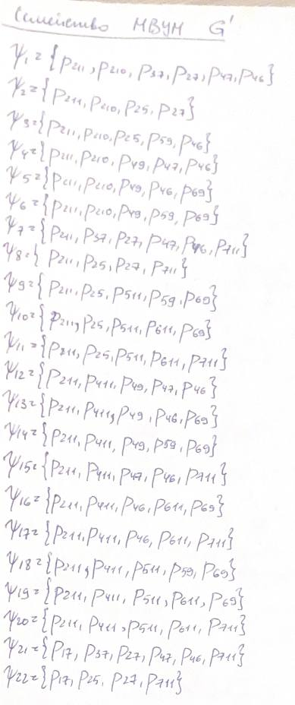

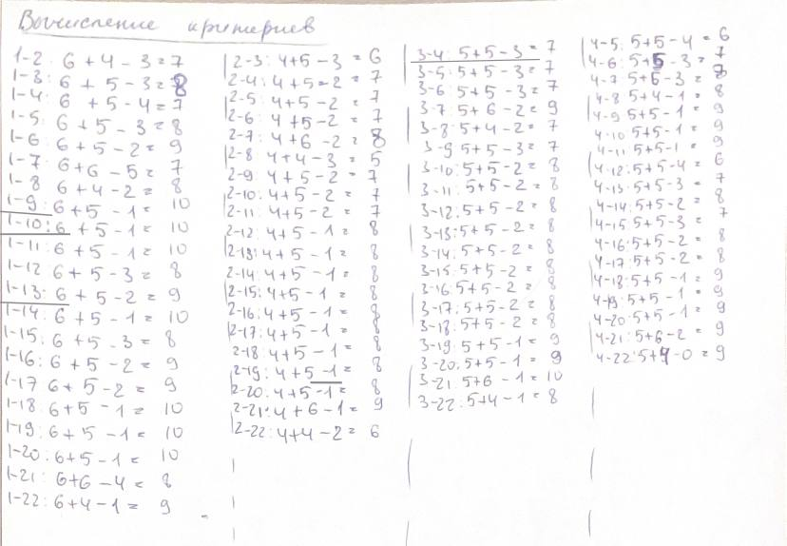

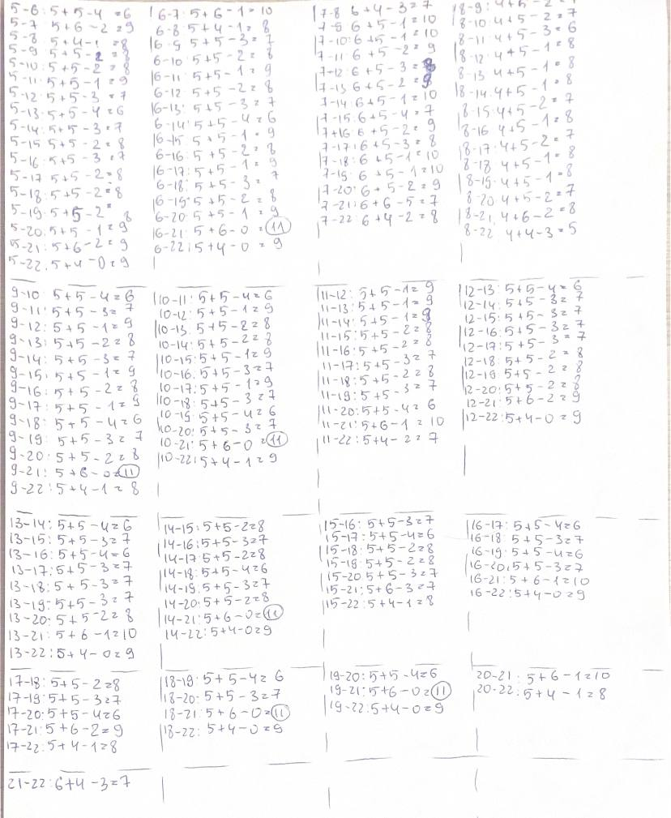

Таблица значений критериев

|  |  |  |  |  |  |  |  |  |  |  |  |  |  |  |  |  |  |  |  |  |  |  |
| --- | --- | --- | --- | --- | --- | --- | --- | --- | --- | --- | --- | --- | --- | --- | --- | --- | --- | --- | --- | --- | --- | --- |
|  | 1 | 2 | 3 | 4 | 5 | 6 | 7 | 8 | 9 | 10 | 11 | 12 | 13 | 14 | 15 | 16 | 17 | 18 | 19 | 20 | 21 | 22 |
| 1 | 0 | 7 | 8 | 7 | 8 | 9 | 7 | 8 | 10 | 10 | 10 | 8 | 9 | 10 | 8 | 9 | 9 | 10 | 10 | 10 | 8 | 9 |
| 2 |  | 0 | 6 | 7 | 7 | 7 | 8 | 5 | 7 | 7 | 7 | 8 | 8 | 8 | 8 | 8 | 8 | 8 | 8 | 8 | 9 | 6 |
| 3 |  |  | 0 | 7 | 7 | 7 | 9 | 7 | 7 | 8 | 8 | 8 | 8 | 8 | 8 | 8 | 8 | 8 | 9 | 9 | 10 | 8 |
| 4 |  |  |  | 0 | 6 | 7 | 8 | 8 | 9 | 9 | 9 | 6 | 7 | 8 | 7 | 8 | 8 | 9 | 9 | 9 | 9 | 9 |
| 5 |  |  |  |  | 0 | 6 | 9 | 8 | 8 | 8 | 9 | 7 | 6 | 7 | 8 | 7 | 8 | 8 | 8 | 9 | 9 | 9 |
| 6 |  |  |  |  |  | 0 | 10 | 8 | 7 | 8 | 9 | 8 | 7 | 6 | 9 | 8 | 9 | 7 | 8 | 9 | 11 | 9 |
| 7 |  |  |  |  |  |  | 0 | 7 | 10 | 10 | 9 | 8 | 9 | 10 | 7 | 9 | 8 | 10 | 10 | 9 | 7 | 8 |
| 8 |  |  |  |  |  |  |  | 0 | 7 | 7 | 6 | 8 | 8 | 8 | 7 | 8 | 7 | 8 | 8 | 7 | 8 | 5 |
| 9 |  |  |  |  |  |  |  |  | 0 | 6 | 7 | 9 | 8 | 7 | 9 | 8 | 9 | 6 | 7 | 8 | 11 | 8 |
| 10 |  |  |  |  |  |  |  |  |  | 0 | 6 | 9 | 8 | 8 | 9 | 7 | 9 | 7 | 6 | 7 | 11 | 9 |
| 11 |  |  |  |  |  |  |  |  |  |  | 0 | 9 | 9 | 9 | 8 | 8 | 7 | 8 | 7 | 6 | 10 | 7 |
| 12 |  |  |  |  |  |  |  |  |  |  |  | 0 | 6 | 7 | 7 | 7 | 7 | 8 | 8 | 8 | 9 | 9 |
| 13 |  |  |  |  |  |  |  |  |  |  |  |  | 0 | 6 | 7 | 6 | 7 | 7 | 7 | 8 | 10 | 9 |
| 14 |  |  |  |  |  |  |  |  |  |  |  |  |  | 0 | 8 | 7 | 8 | 6 | 7 | 8 | 11 | 9 |
| 15 |  |  |  |  |  |  |  |  |  |  |  |  |  |  | 0 | 7 | 6 | 8 | 8 | 7 | 7 | 8 |
| 16 |  |  |  |  |  |  |  |  |  |  |  |  |  |  |  | 0 | 6 | 7 | 6 | 7 | 10 | 9 |
| 17 |  |  |  |  |  |  |  |  |  |  |  |  |  |  |  |  | 0 | 8 | 7 | 6 | 9 | 8 |
| 18 |  |  |  |  |  |  |  |  |  |  |  |  |  |  |  |  |  | 0 | 6 | 7 | 11 | 9 |
| 19 |  |  |  |  |  |  |  |  |  |  |  |  |  |  |  |  |  |  | 0 | 6 | 11 | 9 |
| 20 |  |  |  |  |  |  |  |  |  |  |  |  |  |  |  |  |  |  |  | 0 | 10 | 8 |
| 21 |  |  |  |  |  |  |  |  |  |  |  |  |  |  |  |  |  |  |  |  | 0 | 7 |
| 22 |  |  |  |  |  |  |  |  |  |  |  |  |  |  |  |  |  |  |  |  |  | 0 |

maxαγδ= α6,21= 12, дает пара множеств ψ6, ψ21

Проводим внутри гамильтонова цикла ребра ψ6­, а вне него – ребра ψ21

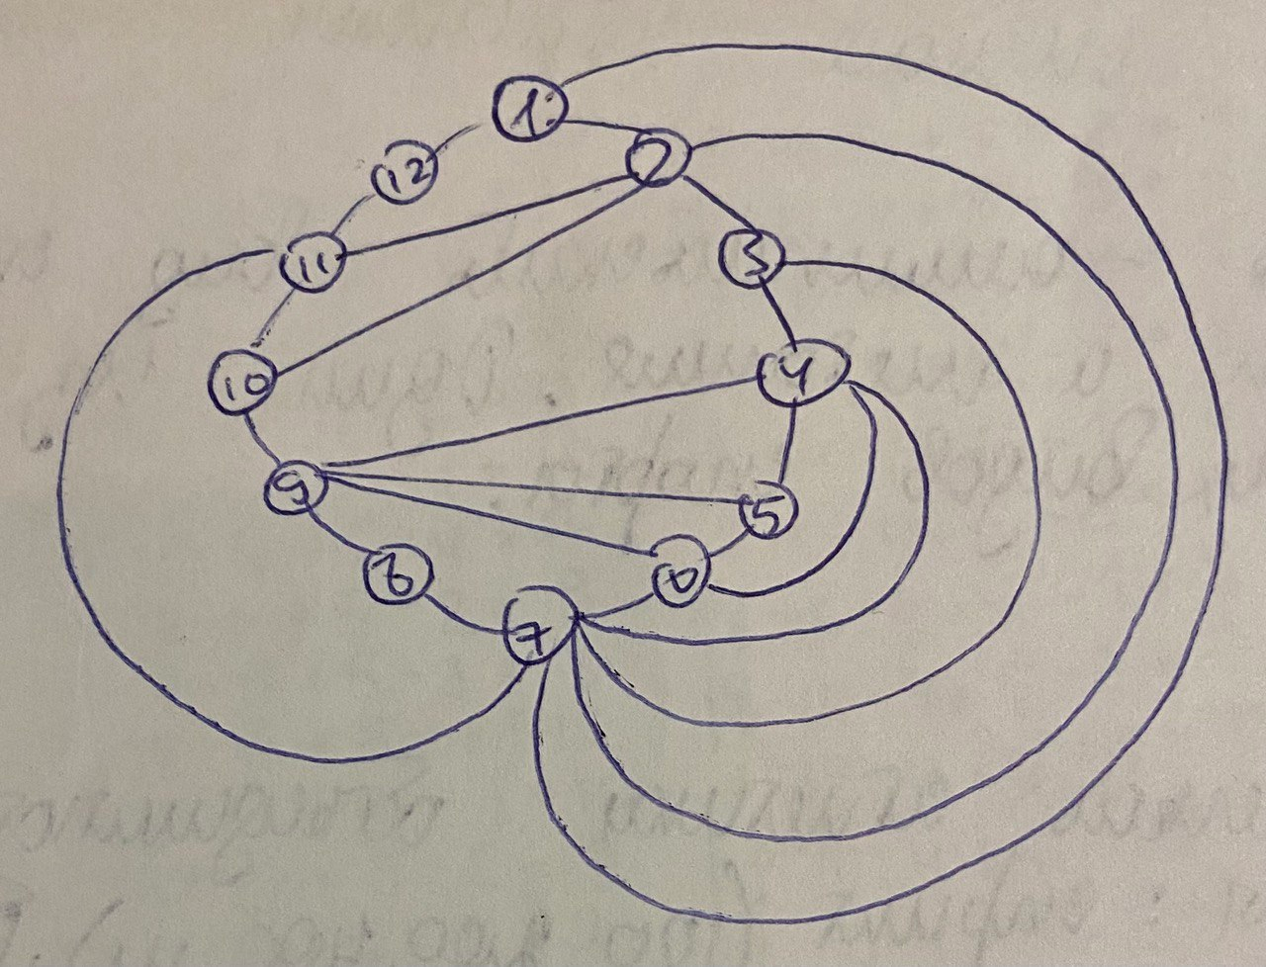

Удаляем из ΨG’ ребра, вошедшие в ψ6­, ψ21

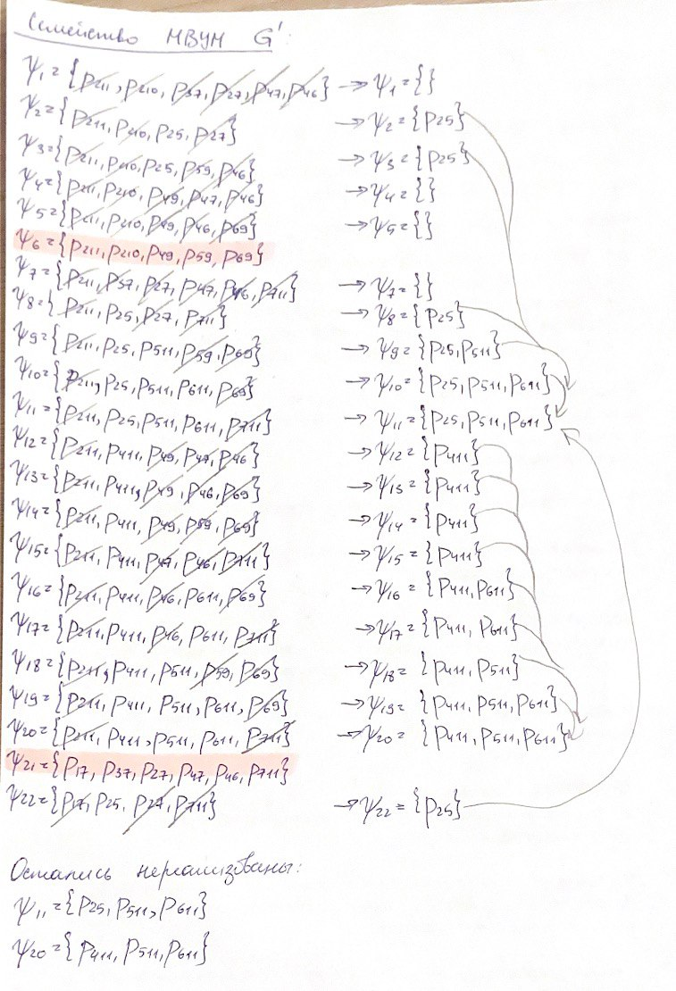

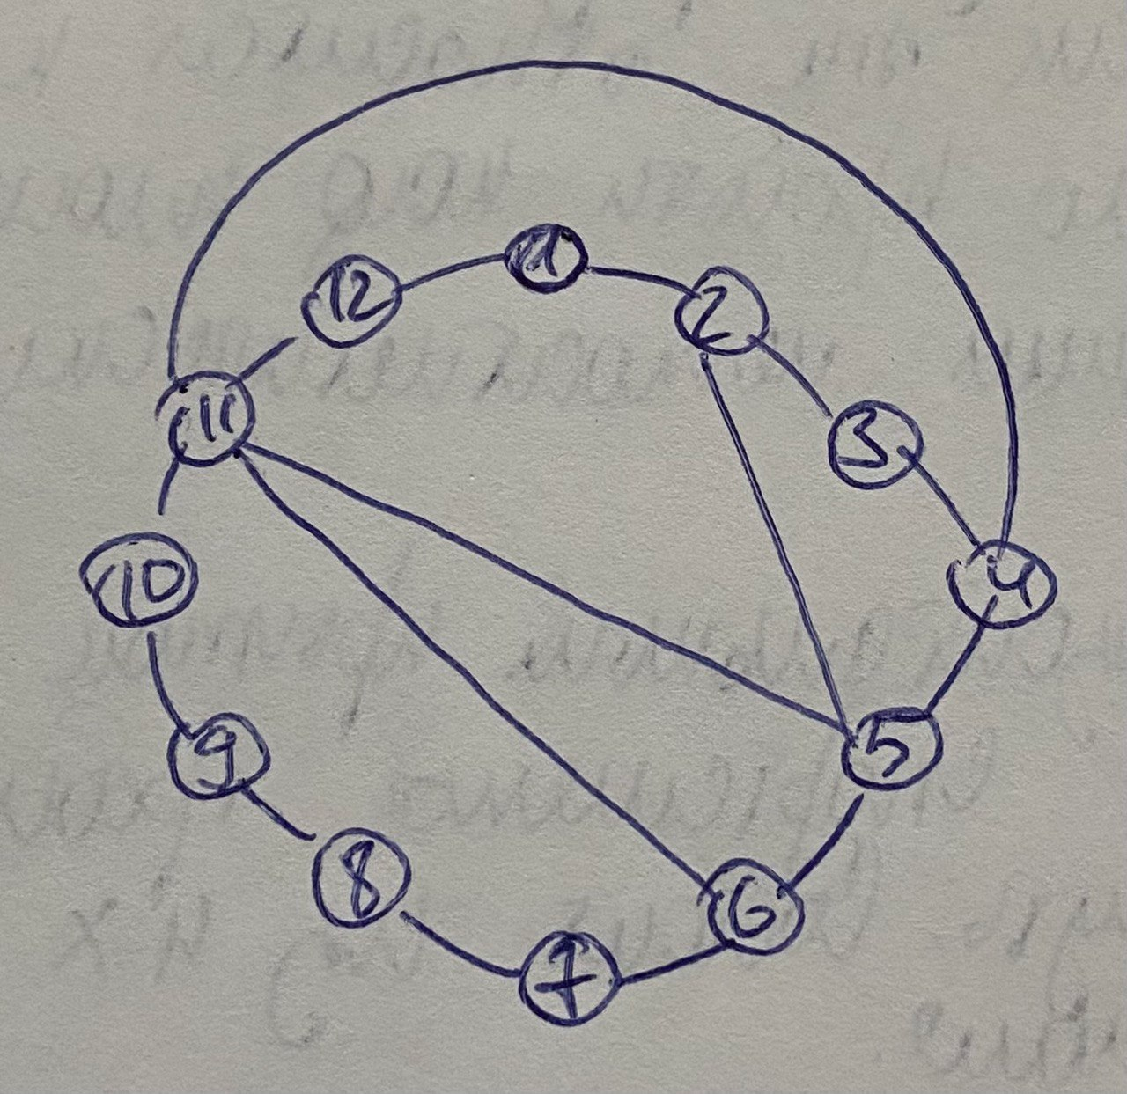

Толщина графа – 2.